2 d Carbohydrates
Most people are familiar with carbohydrates, especially when it comes to what we eat. Athletes often “carb-load” before important competitions to ensure that they have enough energy to compete at a high level. Carbohydrates are, in fact, an essential part of our diet. Carbohydrates provide energy to the body, particularly through glucose, a simple sugar that is a component of starch and an ingredient in many staple foods.

Molecular Structures
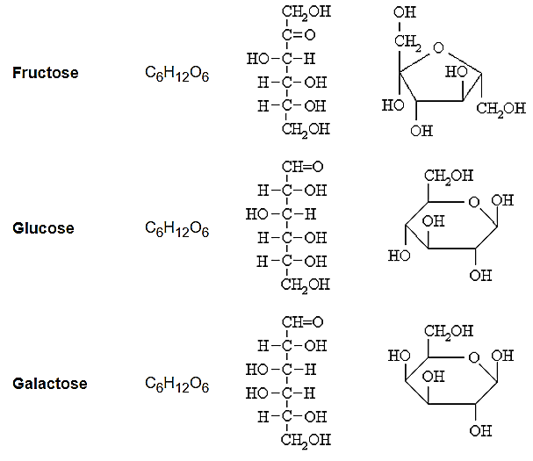
Carbohydrates can be represented by the stoichiometric formula (CH₂O)_{n}, which can also be written as C_{n}(H₂O)_{n} where n is the number of carbons in the molecule. In other words, the ratio of carbon to hydrogen to oxygen is 1:2:1 in carbohydrate molecules. This formula also explains the origin of the term “carbohydrate”: the components are carbon (“carbo”) and the components of water (hence, “hydrate”).
Carbohydrates are often referred to as sugars. But this term can be misleading because not all carbohydrates are sweet. The simplest carbohydrates are monosaccharides. These are molecules which contain 3 to 6 carbons. Most common simple sugars or monosaccharides (glucose, fructose, and galactose) contain 6 C’s, although ribose is one exception as it contains 5 C’s. This unit will refer to 6C monosaccharides in almost all of its examples.

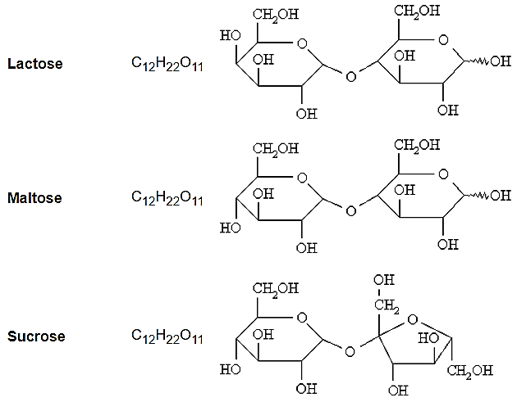
Other simple sugars are disaccharides – which contain two monosaccharides joined together with a glycosidic link between them. Some example of disaccharides are Sucrose, Lactose, and Maltose.
More familiar to you will be the term “complex sugars”, as these are considered the more healthy eating option. Some of these are oligosaccharides, which contain 3 to 10 C units. These will not be discussed in this topic. The largest complex sugars are polysaccharides, which contain more than 10 carbons. Some common polysaccharides are cellulose in plants and starch in plants, and glycogen in animals.

MONOSACCHARIDES
The most common monosaccharides have 6 Cs in them and because they share very similar molecular formula they are isomers of each other.
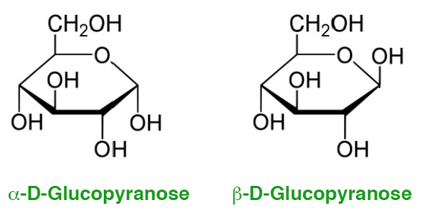
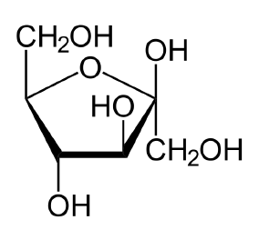
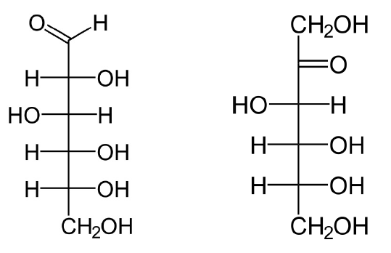
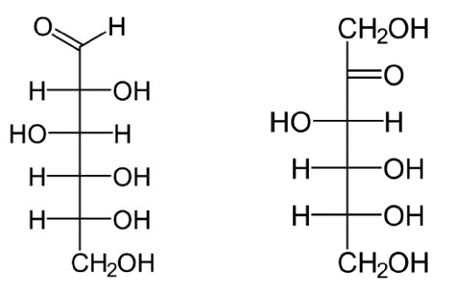
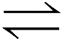
All monosaccharides exist in aqueous solution as two configurations in equilibrium – a straight chain of six carbons and a ring structure. Mostly these molecules are drawn in text books as a ring formation, but both forms are equally correct, and understanding the straight chain form can explain the structure of the ring configuration.
Glucose
Fructose
1
2
3
4
5
6
1
2
3
4
5
6
1
2
3
4
5
6
1
2
3
4
5
6
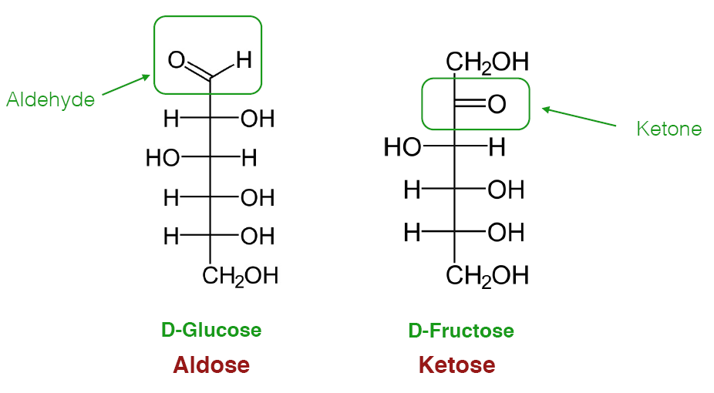
Notice the similarities and differences in the structures of glucose and fructose. The differences are caused by the positioning of the carbonyl group. In glucose it is an aldehyde, but in fructose it is a ketone. This difference influences which carbon forms the ring structure. In glucose it is the 1C and 5C, in Fructose it is the 2C and 5C – so they have different cyclic structures. In fact monosaccharides are classified according to this major difference.
These monosaccharides are referred to as aldose monosaccharides
These monosaccharides are referred to as ketose monosaccharides
When forming the ring configuration from the linear configuration, the double bond between the 1C (in aldoses) or 2C (in ketoses) and the O atom breaks and this O atom bonds to a H atom to form an OH functional group. The 1C, or 2C atom then forms a bond with the O atom attached to the 5C atom, making a cyclical structure with one O atom as part of the ring. This creates a situation where the newly created OH group can assume one of two positions, above the plane of the ring (up) or below the plane of the ring (down). These two differences create an α- and β - form of each molecule.
These is α-Glucose.
The OH group on the 1C is in the “down” position
These is β-Glucose.
The OH group on the 1C is in the “up” position
The difference between these two forms of glucose have very significant implications in nature. Cellulose, starch and glycogen are all polymers of glucose. Cellulose is made from β-Glucose and is indegistible (to many animals) and provides a rigid structure for plants. Starch and glycogen are made entirly from α-Glucose and are easily digestible.
POLYSACCHARIDES
All of the most common polysaccharides (starch, glycogen, and cellulose) are made from glucose monomers. The connections between the glucose molecules varies however, and this makes a significant difference to the physical properties of the polymer (polysaccharide).

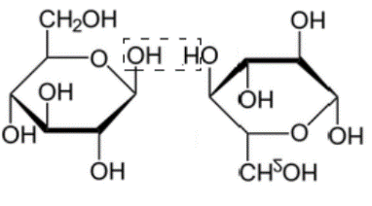
Cellulose – is formed entirely from β-Glucose molecules and β-1,4-glycosidic links between the glucose molecules. In addition, every other (second) glucose molecule is inverted. This joining is shown is the diagram on the right.
β-Glucose with “up” OH group
Inverted β-Glucose. The 1C with the “up” OH now appears to be down.

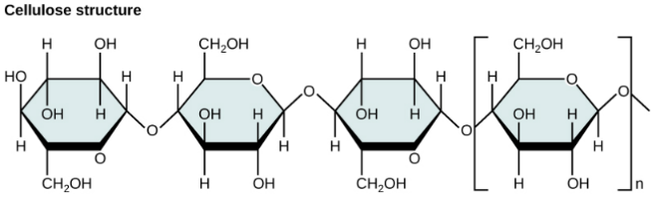
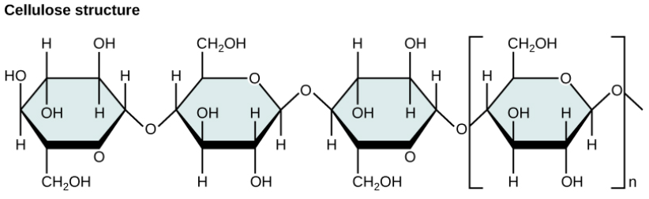
This linking creates a polymer which is very uniform and symetrically linear, and this allows the polymer chains to fit closely together and intermolecular forces (which include hydrogen bonding) are able to hold the ploymer chains very tightly together. It has quite high tensile strength, so can be used as a structural ccarbohydate in plants (much like a skeleton). It also means cellulose is quite dense, and not soluble in water. The digestive enzymes in most animals cannot break β-1,4-glycosidic links and cellulose is therefore indegistible to most animals.

Starch – is formed from α-Glucose molecules. There are two forms of starch amylose and amylopectin. Both are made from α-Glucose, but differ slightly in the glycosidic linkages between the glucose.
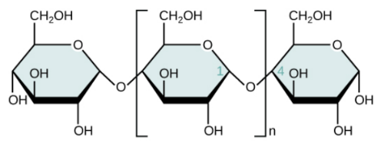
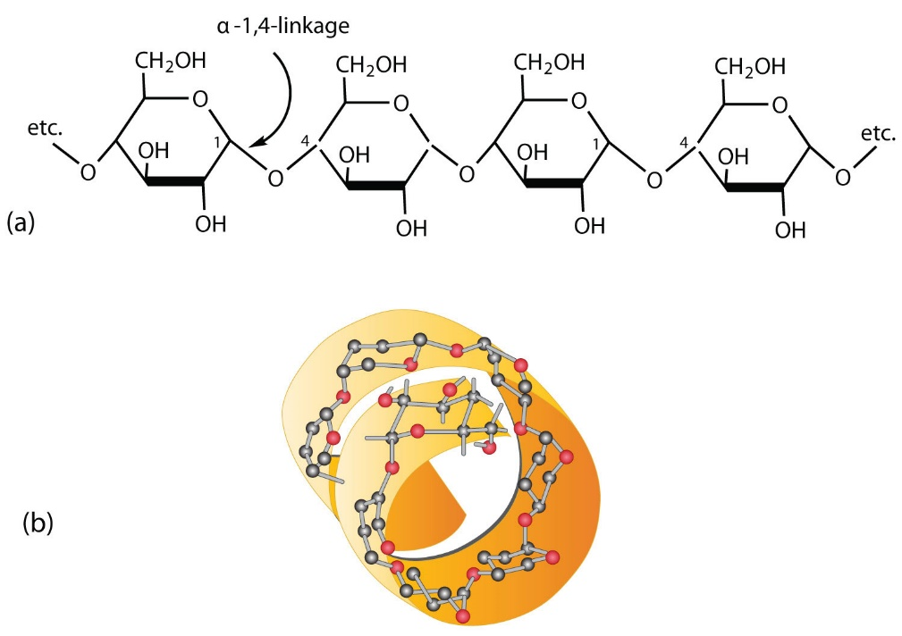
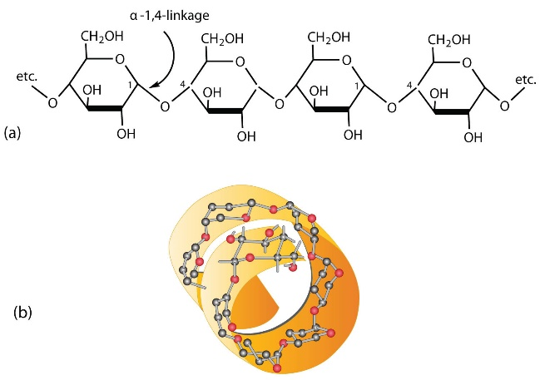
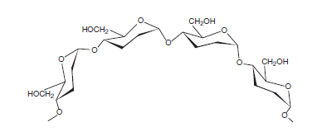
Amylose – has only α-1,4 glycosidic links between the molecules. In the diagram below, the glucose chain looks linear, however the angle created by the repeating α-1,4 links cause a spiral structure to the polymer. Amylose has a spiral (helix) structure rather than linear. This means the intermolecular forces (including hydrogen bonding) has less an effect than cellulose, and Amylose is less dense and is water soluble (to some degree). The digestive enzymes in all animals can digest α-1,4 glycosidic links, so amylose is readily digestible.

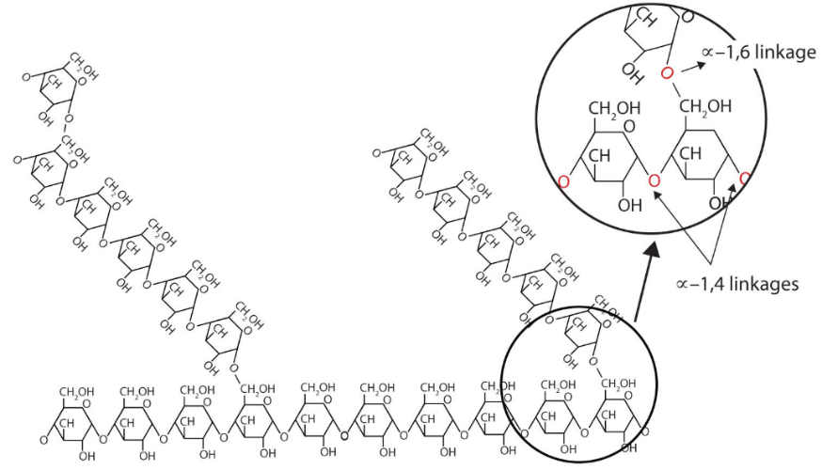
Amylopectin – has α-1,4 glycosidic links between glucose molecules (like amylose), but also has additional α-1,6 glycosidic links joining chains together. This means that in AmyIopectin some of the glucose molecules form 3 glcosidic links. This causes Amylopectin to have “branches” within its polymer structure. Around these branched units the polymer cannot form a spiral structure, so amylopectin has a combined spiral and branched appearance. Amylopectin is less soluble that amylose because the branches cause a more globular general shape and fewer intermolecular attractions with surrounding water molecules. It is also less dense. The α-1,6 glycosidic links are also easily broken by digestive enzymes in most animals so amylopectin is readily digestible.
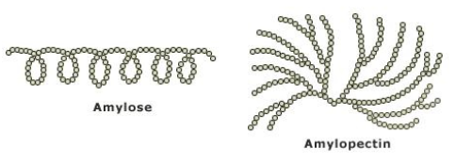

Glycogen – is the polymer formed in the liver with excess glucose molecules – when high blood sugar occurs. It is similar to amylopectin as it has α-1,4 glycosidic links and some α-1,6 glycosidic links. However glycogen has a higher percentage of α-1,6 glycosidic links and is more branched as a result. Because of this it tends to be densly globular in shape and this reduces solubility in water.

Questions
- What single defining characteristic allow a molecule to be quickly categorised as a carbohydrate? (hint – formula)
- What functional group is most common in all carbohydrates?
- What function groups exist in the straight chain form of monosaccharides, and how do these impact the structure of the ring configeration of the monosaccharide?
- Draw α-glucose and β-glucose and identify the difference in their structure.
- Explain why the properties of cellulose are different to those of starch, even though both are polymers of glucose.
- Why does amylopectin have slightly different physical properties to amylose?
- Write structural formulas showing the condensation reactions:
(a) between two monosaccharides to produce lactose (see p.1 for lactose structure, α-galactose and α- or β- glucose (use the wavy line to show it could be either))
(b) between two monosaccharides to produce maltose (see p.1 for maltose structure, α- glucose and α- or β- glucose)
(c) between two monosaccharides to produce sucrose (see p.1 for sucrose structure, α-glucose and fructose)

